Revision 2.0, April 2004
How to adjust a Robinson R22 Governor for the Safari (Baby Belle) helicopter.

This document explains how to adjust a R22 governor model B286-2 electronic control board for use in the Safari helicopter.

The Governor control of a R22 is based on an electronic board, which gets a RPM signal from the auxiliary points on the second magneto of the Lycoming OH-320 or OH-360 engine. The board controls an electric 12-volt DC motor, which adjusts the throttle on the engine.
The R22 governor is set to keep the Rotor RPM of the R22 helicopter at 530 RPM, which in case of a R22 is considered 104%, or “top of the green”.
This is equivalent to an engine RPM of 2652 RPM.

Unfortunately, these settings are not suitable for a Safari helicopter, because:
- The default rotor RPM is less than an R22 and
B) The gear ratio between engine and rotor is different.

Below are the differences between the R22 and Safari helicopters.

Engine / Rotor RMP for R22:
Gear ratio 1:5.0

Tacho Engine Freq. Rotor Description
-------------------------------------------------------
104% 2652 88.40 530 Top of the green
100% 2550 85.00 510 Middle of the green
97% 2473 82.43 495 Low RPM horn
80% 2040 68.00 408 Governor switch off

Required RPM for Safari:
Gear ratio 1:5.5

Tacho Engine Freq. Rotor Description
------------------------------------------------------
104% 2860 95.33 520 High
102% 2805 95.00 510 Maybe
100% 2750 91.67 500 Default RPM
97% 2667 88.90 485 Low

The column “Freq.” is the actual frequency of the signal coming out of the magneto on the Lycoming engine.
The magneto produces 2 pulses per revolution of the engine. So to calculate the frequency or RPM use the following formula: RPM = (Frequency / 2) * 60 seconds.

Note that RPM stands for Revolutions Per Minute, and a frequency is in Cycles per Second!
So, a signal out of the Lycoming magneto with a frequency of 170 Hz means the engine is running at (85 / 2) * 60 = 2550 RPM.
The R22 helicopter has a gear ratio of 1:5.0 So, an engine RPM of 2550 gives a Rotor RPM of 2550 / 5 = 510 Rotor RPM.

The Safari helicopter has a gear ratio of 1:5.5. This means that if a R22 governor is installed in a Safari helicopter, the rotor RPM is going to be 482 RPM, which is to low.

What should the Governor be set to in a Safari?

When the Robinson R22 was designed, they where not planning on a Governor. The correct rotor RPM was to be 510 RPM, which is the ‘middle of the green’ or 100%. The bottom of the green is around 495 RPM 97%, and the top of the green is 530 RPM or 104%.
In real live, with the pilot manually adjusting the power, the RPM would fluctuate within the ‘green’ area (we should hope).
When the Governor was introduced, Robinson decided to set the Governor controlled RPM at 530 or 104% !
This was done, I assume, to give the Governor some time to respond, while staying above the 100% mark, in case of an abrupt heavy load, and to get in fact a bit more power on average.
So, while the 100% RPM mark is 510 RPM, the modern R22 flies in fact all the time at 530 RPM or 104%.

The Safari helicopter was also not designed for a Governor. The ‘middle of the green’ for the Safari is 500 RPM, which we will call 100%. If we would follow the example of the Robinson factory, we should set the Governor in a Safari also to 104%, which is 520 RPM on the rotor. This also means an engine RPM of 2860.

There are several issues here. First of all, the Lycoming O-320 engine has a factory maximum of 2700 RPM. The Safari helicopter already exceeds this when flying at 100% or 500 Rotor-RPM, as the engine is then running at 2750 RPM.
Running the engine at 2860 RPM is really pushing it.
(Note: The Lycoming O-360 engine, which is identical to a O-320 except for a different crankshaft and larger stroke, has a factory maximum of 2900 RPM. Go figure…).

On the other hand, a Governor is not a human. It does not know you are about to pull the collective in your armpit. It needs a bit of time to increase the throttle to compensate. You will lose some RPM in aggressive maneuvers. You therefore need a bit of room on the bottom end of the RPM.

After the first revision of this document was distributed, I got some feedback from Mark Richards from Canadian Home Rotors.
Mark says:

“We consider "top of green" 500 RPM. I have done considerable testing of high RPM limits last year. I found that on the old thin wall mast transmission any RPM above 518 is likely to result in high vibration levels. On the new transmissions or old ones that have been upgraded to the heavy wall mast there is no problem with vibration to a much higher RPM.
But there is another consideration. Our main rotor grip bearings are operating very near their max centrifugal load limit. Over speeding the rotor will shorten their life considerable. I would recommend 495 RPM.”

I would personally suggest that a figure of 500 RPM is used. As the governor is keeping the RPM under a much better control than a human being, I think that the final result will be a much longer live on the bearings when using a governor.

In the chapter on how to adjust the Governor, I have made a table to show the ‘Target Frequency’ for various rotor RPM settings.

The R22 Governor in detail.

When I started to look into the R22 Governor control unit, and did some testing, I found that the unit does a bit more than I expected. Basically it uses a Tacho IC (Integrated Circuit), which turns a frequency signal into a voltage. The higher the frequency, the higher the voltage. These IC’s are standard in most Tacho instruments. It is now possible to add some components which turn a 12-Volt motor one way when the control voltage gets to low, and the other way when the control voltage gets to high. Presto! A RPM control system.

But… The R22 unit does a lot more.
First of all, it does not just switch the 12-Volt motor (which moves the throttle) on and off (in both directions); It actually changes the speed of the motor depending on how far of the preset RPM you get. If you are only just getting a bit to high or low compared to the preset RPM, the motor will start to turn very slowly. If you get far of the required RPM, the motor will get to full speed. This gives a very smooth RPM control, and prevents ‘overshoot’ and ‘searching’ effects.

But there is more! There is of course an area around the required RPM where the motor will not turn at all. A window between a high and a low RPM in which the Governor will not correct the RPM. This is to prevent the motor of continuously switching forwards and backwards.
This window is in fact quite big, in the governor I tested between 524 and 539 RPM the motor does not run. I found this quite strange. But then I discovered something else. Inside this ‘dead’ window, the motor got a short burst of power every time a quick change of RPM occurred within this window. For example, say the RPM is at 530. I change this to 535. The moment the RPM changes, the 12-Volt motor gives a quick short burst in the opposite direction, and then stops again! It looks like this weird feature is what does the fine-tuning within the area close to the required RPM.

Testing and adjusting the Governor

I build a test generator using a NE555 IC, which emulates the signal coming out of a Lycoming magneto.
However, a stable signal generator with a square wave output of several volts will work as well, when connected directly to pin 1 of the first tacho IC. It will not work if connected to the normal input of the box, due to the various filters that are installed in the unit.
Note that the signal generator must be capable to generate a very stable signal in the 90 Hz range with at least one-tenth of a Hz resolution, and the cheap generators will not be able to do that.

(Also see Alternate tuning option described below.)

The other equipment you will need is a digital frequency counter.

With above equipment I tested the Governor and got the readings below.

Actual readings from the Governor I tested:

Tacho Engine Freq. Rotor Description
-----------------------------------------------------------------------------------------------------
102.7% 2619 87.30 523.8 Bottom, first pulse to motor, no movement yet
101.2% 2520 84.00 504 Bottom, motor max power
105.65% 2694 89.80 538.8 Top, first pulse to motor, no movement yet
109.41% 2790 93.00 558 Top, motor max power

We know that the preset RPM for a R22 is 530, which equates to a frequency of 88.40 Hz,
At the low end of the RPM, the first pulse to the motor occurs at 87.30 Hz. This is (88.40-87.30)= 1.1 Hz difference. That is, the first pulse to the motor occurs at 1.1 Hz below the required RPM.

The Conversion to the Safari

So now we are ready to change the settings on the Governor. In the following table you can see what Target Frequency is required for various Rotor RPM settings.

The formula is: (RotorRPM x 5.5) = Engine RPM. (EngineRPM / 60) x 2 - 1.1 = Target Frequency in Hz.

Rotor RPM Target Freq.
--------------------------------
510 RPM 93.0 Hz
505 RPM 92.58 Hz
500 RPM 91.67Hz
495 RPM 90.75 Hz
So, we have to adjust the Governor so that the first pulse to the 12-Volt motor occurs just as we reach the Target Frequency.

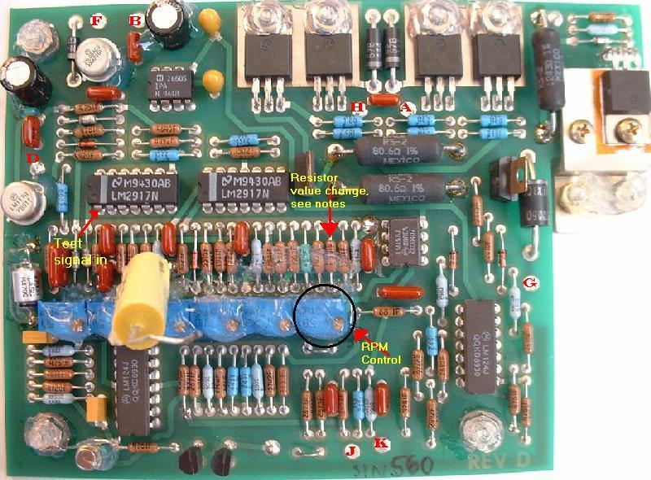
Shown above is the circuit board of the B286-2 Governor.
There are 6 adjustable pot-meters. Of these only one should ever be touched, which is the one marked ‘RPM Control’. Do NOT adjust any of the other pots!
If a test generator is used to feed the controller, the best thing to do is to insert the signal directly in pin 1 (one) of the left LM2917, marked ‘Test signal in’ above. This bypasses some protection circuits and resistors, which require the signal to be a full 12 volt signal going completely to ground; On Pin1 the signal can be much smaller, and does not have to go fully to ground.

Because the RPM pot-meter does not have enough range to reach the frequency required for the Safari helicopter, an extra resistor must be soldered on the back of the board as in the picture below.
This resistor must be 47 Kilo ohms, 1 (one) percent. The color code for this resistor is either yellow-purple-orange---brown, or yellow-purple-black-red---brown, where the last color brown indicates the one percent quality of the resistor. Do NOT use any resistors that have a gold or silver band as the last color. These are 5% or 10% resistors, and should NOT be used here.
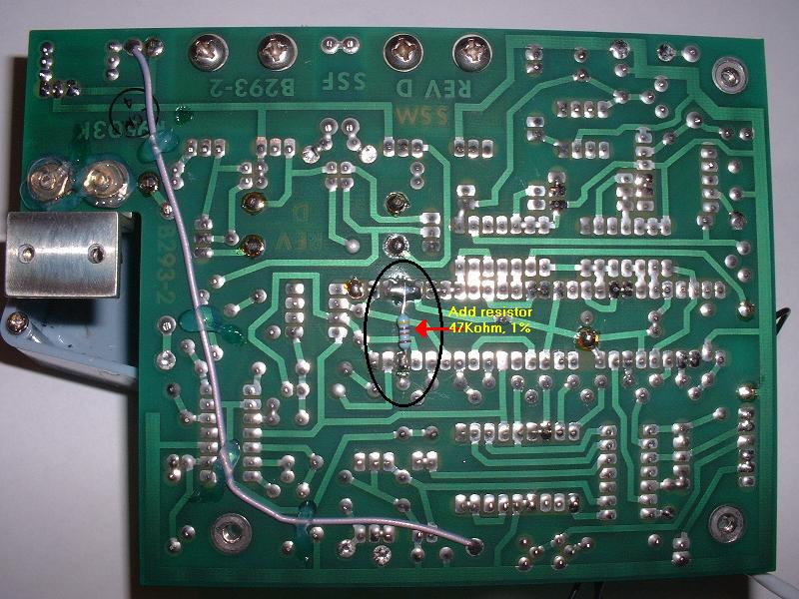

Remove the board from the case and carefully solder the new resistor in place. Reinstall the board into the case.
Cut of the silicone that covers the RPM pot-meter, so you can reach the adjustable screw. This is a 10 or 15-turn pot-meter.

TUNING WITH A SIGNAL GENERATOR

Connect the motor to the board, and power it up on 12 volts. Insert the test signal on pin 1 of the LM2917, and have a frequency counter also connected to the signal generator.
Set the generator the Target Frequency. At this point, the motor should be running flat-out.

Start turning the RPM pot-meter until the motor starts slowing down. Keep adjusting, stopping every time for a moment, until the motor is no longer moving, but a ‘whining’ sound can be heard from it. This is a very delicate adjustment. At this point the motor is only just receiving its first pulse, but is not yet turning.

Now confirm the adjustment by changing the frequency on the test generator. If the frequency is slightly higher than the Target Frequency, the motor should not run. When lowering the frequency to the Target Frequency or lower (and pausing every time for the system to stabilize) the motor should start running. The point at which the motor just start making a ‘whining’ sound, but is not yet running should be at the Target Frequency. Also test at which point at the high-end of the scale the motor starts running in the opposite direction. This should be around 2.5 Hz above the Target Frequency (first ‘whining’ sound).
The Governor will completely cut out automatically below 68 Hz. This is a safety feature, and it means that if the engine is running at idle (75% rotor RPM or below in a R22) the governor will not attempt to bring the RPM up to its programmed RPM. When the power is brought up by hand to 80% or above, the governor will kick in, and move the RPM to the programmed RPM. This is quite an abrupt power surge, and will cause a short over-RPM. It is always better to bring the RPM up to 100% by hand with the governor switched off, and then turn it on. This is only a small power adjustment. That is the way we do it in a R22.

Once the adjustments have been completed, apply new silicone to the pot-meter to prevent it changing due to vibrations.

See next page for wiring diagram.

ALTERNATE TUNING IN HELICOPTER

For some people it seems to be very difficult to get the test equipment and follow the above recommended procedure. Therefore I describe this alternate option, which is done with the governor installed in the helicopter.
To do it this way, you MUST have a way to accurately measure either the frequency of the magneto pulse, or the Rotor RPM. Do NOT use a Tacho as a reference, as they cannot be trusted until they themselves have been calibrated!! I know of near disaster happening because the Tacho was over reading by 100 RRPM or so, so that the helicopter was flown with only 400 RRPM which is near blade stall.

Add the resistor to the board as described above, but do not change the pot meter position.

First make sure all other bits in the helicopter work correctly and the rotor system has been balanced.
Put the helicopter on a soft surface (grass) else you will have major shakes at lower RPM.
Tie down the collective so it cannot come up under any circumstances, but make sure that the throttle can turn freely at the same time. Have somebody sitting at the controls at all times.
Have a frequency counter or RRPM counter ready to measure the magneto frequency or (better) the Rotor RPM. With the governor switched OFF, bring the Rotor RPM up to 500. Hold the throttle tightly and switch ON the governor. Confirm that the governor it trying to decrease the RPM, not increase! If it tries to increase, you may have the motor wires inverted. Never let the RRPM get much above 500.
If the governor is decreasing the RPM, slowly let the throttle slip until the governor settles down to a certain RPM. Then start adjusting to pot meter until you have the RPM where you want it (recommended 500 RRPM).

I have never done this procedure myself, but it should work. The only snag I can think off, is a situation where the position of the pot meter at the start of this procedure is higher than 500 RRPM. From memory, after installing the resistor on the board and not touching the pot meter, this should not be the case.
However, if the governor is trying to increase the RPM from 500, AND you are sure that the motor wires are NOT inverted (and this depends on the way you have installed it!), you may have to turn the pot meter way back and try again.
Always hold on to the throttle and don’t let the governor run away on you to 500+ RPM!

Motor Installation

You have to install the 12-Volt motor in such a way that a 90 degree turn of the motor corresponds with a full range of the throttle. So from idle to max power should be a 90-degree turn, approximately (in practice, it seems to be less than that, see the pic's on my own installation).

Also, it is Very Important that the throttle control is easy to turn, and not tight! There should be NO friction applied, either intentionally of because of the way the throttle control was build. If the system is to tight, the Governor will not be able to make the small power adjustments at low motor rpm, that is, the motor should be able to move the throttle when getting a ‘slow’ signal from the governor, not just when a full 12-volt is applied!
I understand that due to the welding in some helicopters, the various tubes bend, with the result that the throttle is difficult to turn. This MUST be rectified if the governor is to operate properly.

Another important issue is the correlator. This is the connection between the collective and the throttle control, which increases the throttle when the collective is raised.
It is very important that this connection is adjusted carefully, so that above approximately 17” of manifold pressure, the RPM stays the same when lifting the helicopter of the ground into a hover. If the correlator is correctly adjusted, almost no manual change should be required when hovering, going through translational lift into forward flight, and back again. The R22 is very good at this.
Especially, when translating from forward flight, through translational lift, into a ground effect hover, you should not have to increase throttle.

Please note that the better the correlator is set up, the less likely it is that the governor cannot cope with a sudden power requirement, as the correlator already does most of the work. The governor is basically just doing the fine-tuning.

You can find pictures of my Correlator and Governor installation on my web site at:

http://www.bart.gen.nz/safari/governor/

Note the change in the seat-frame I had to make to make enough room for the top correlator arm, which needs to be this long for the correlator to be effective enough.
The longer this arm is, the more correlation (power) you get when pulling the collective up.
I used a short length of steel tube over an AN3 bolt.

Also note the location of the Governor motor: It MUST be located AFTER the correlator arm, and NOT on the other side where it goes into the engine, else the correlator will no longer work!

In the position shown here, the motor wires must be inverted from the default R22 wiring, else the governor will work backwards (try to increase the RPM when it is already to high).
Wiring diagram.
The Governor connector pin information on all Robinson wiring diagrams IS COMPLETELY WRONG. (Note: Probably because they have modified the connector, which is installed upside down!)
See below the correct pin configuration on the socket on the governor box, that is, the male connector on the governor itself! I understand there is a chance the R22 male connector is fitted upside down, which means that the pin configuration on the male connector is different then on the actual socket on the box.

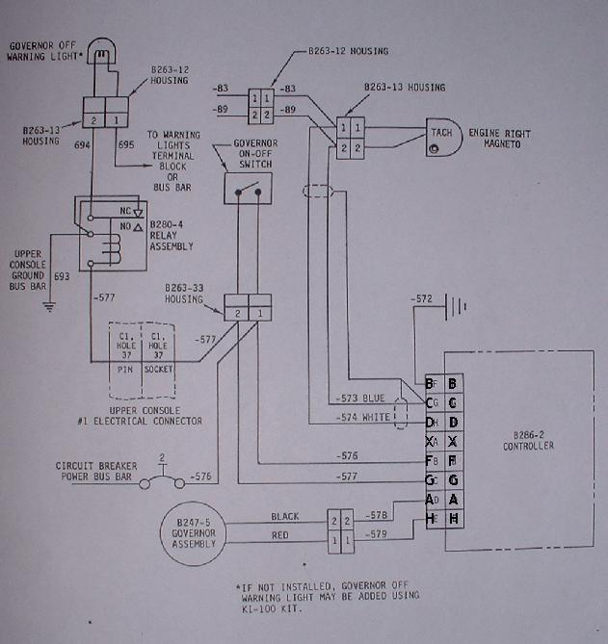

NOTE: The 12-Volt Motor connections in above diagram could be the wrong way around (A+H). Please make sure when doing the first test in the helicopter, that the throttle control motor goes in the right direction! If the RPM is to low, the motor should Increase the power, not decrease it…!
SAFETY INFORMATION.

LABEL THE GOVERNOR ON THE INSIDE AND ON THE OUTSIDE THAT IT HAS BEEN MODIFIED FOR A SAFARI HELICOPTER AND CANNOT BE USED UNDER ANY CIRCUMSTANCES FOR USE IN A ROBINSON R22 HELICOPTER AGAIN. SERIOUS DAMAGE MAY OCCUR IF THIS GOVERNOR WOULD BE INSTALLED IN A R22 HELICOPTER, AS IT WILL OVERSPEED THE ROTOR SYSTEM. IT IS ILLEGAL TO INSTALL THIS GOVERNOR IN A ROBINSON R22 HELICOPTER AFTER IT HAS BEEN OPENED, LET ALONE MODIFIED.

PLEASE, PLEASE DO LABEL the Governor!!! It is quite possible that some years in the future someone may lay there hands on it, and attempt to install it again in a R22! This could be VERY expensive!

--------------------------------------------------------------------------------------------------------------------------------
I am no longer doing governor conversions for other Safari owners, as it became too much of a hassle, sorry!
--------------------------------------------------------------------------------------------------------------------------------

Good luck,

Bart

chopper @ bart.gen.nz

First Revision 1.0, 25 May 2002
Revision 1.1, 2 June 2002: Added note about tightness in throttle control.
Revision 1.2, August 2002: Amendments regarding the required rotor RPM, more on friction in the throttle control, and extra remarks on the correlator adjustment.
Revision 2.0, April 2004: Major error regarding the frequencies fixed, as the magnetos generate a signal 2x the engine RPM and not 4x as originally assumed. This had to do with a weird side effect of my homemade signal generator. Also added more info on physical installation and alternate tuning option.

